Lab 1
Local host server:
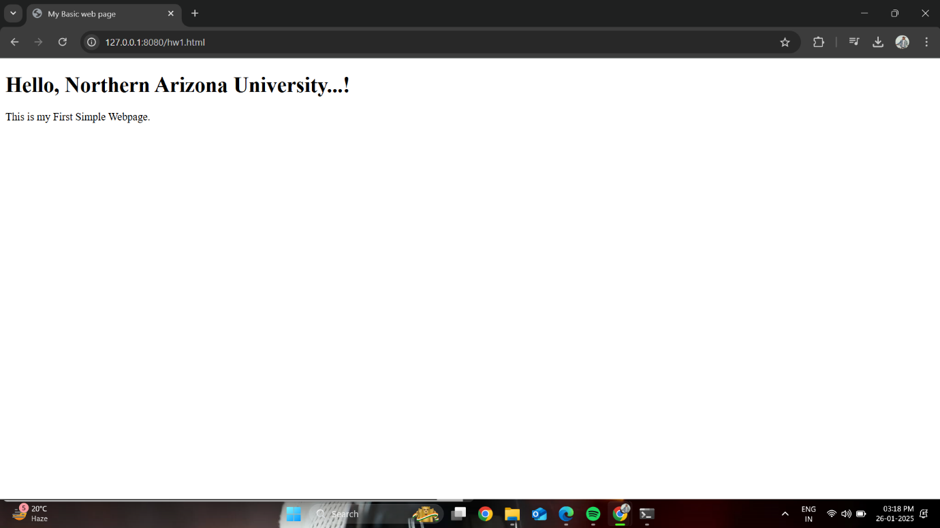
Link: http://127.0.0.1:8080/hw1.html

Azure server:
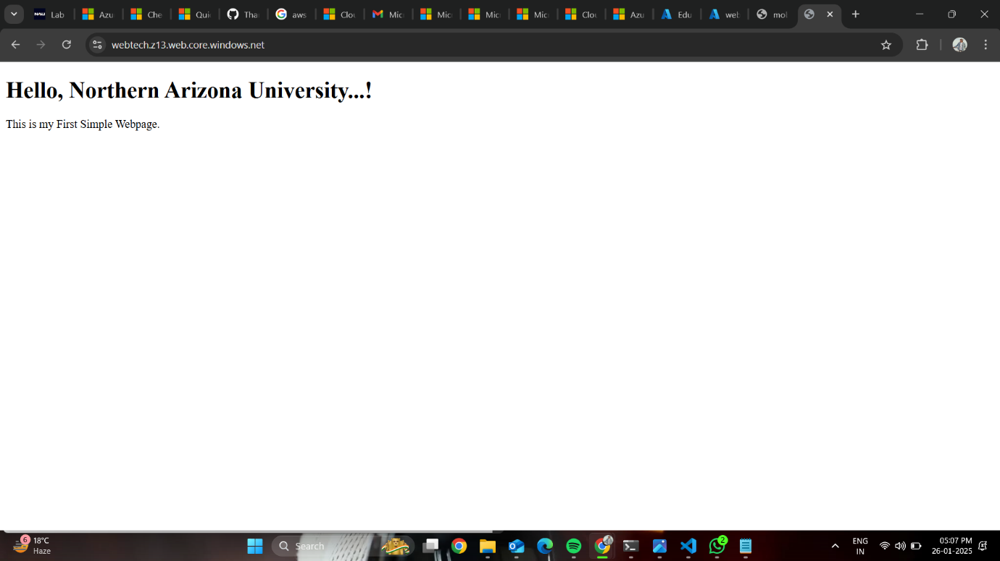
Link: https://webtech.z13.web.core.windows.net/
Github server:
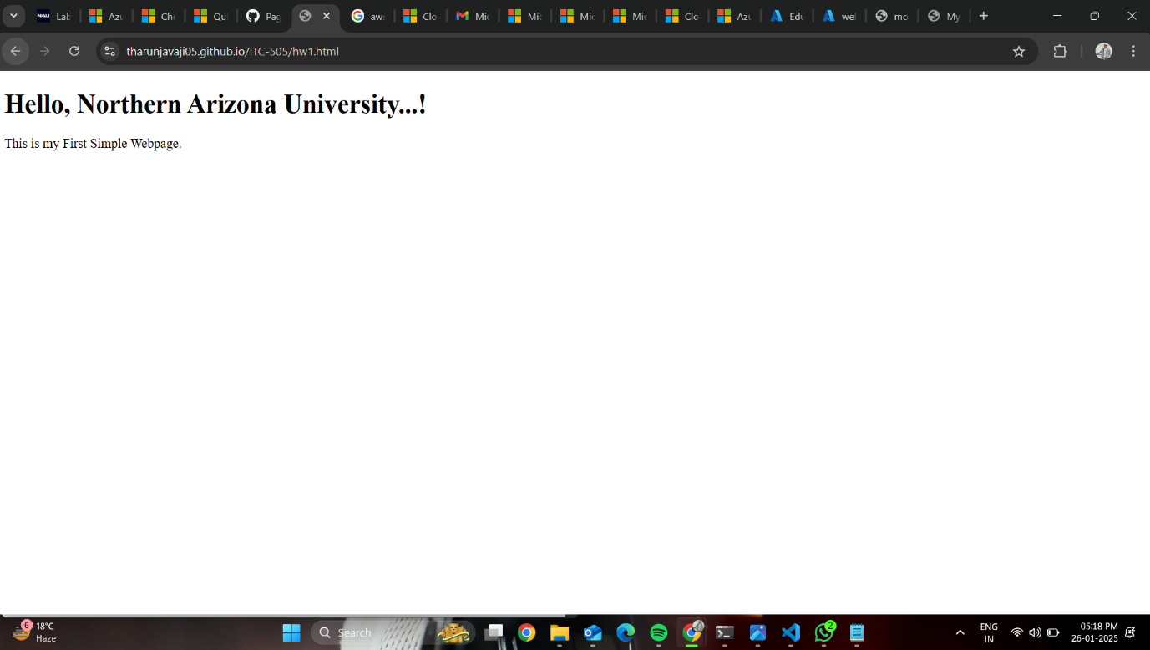

Link: https://tharunjavaji05.github.io/ITC-505/hw1.html

AWS SERVER:
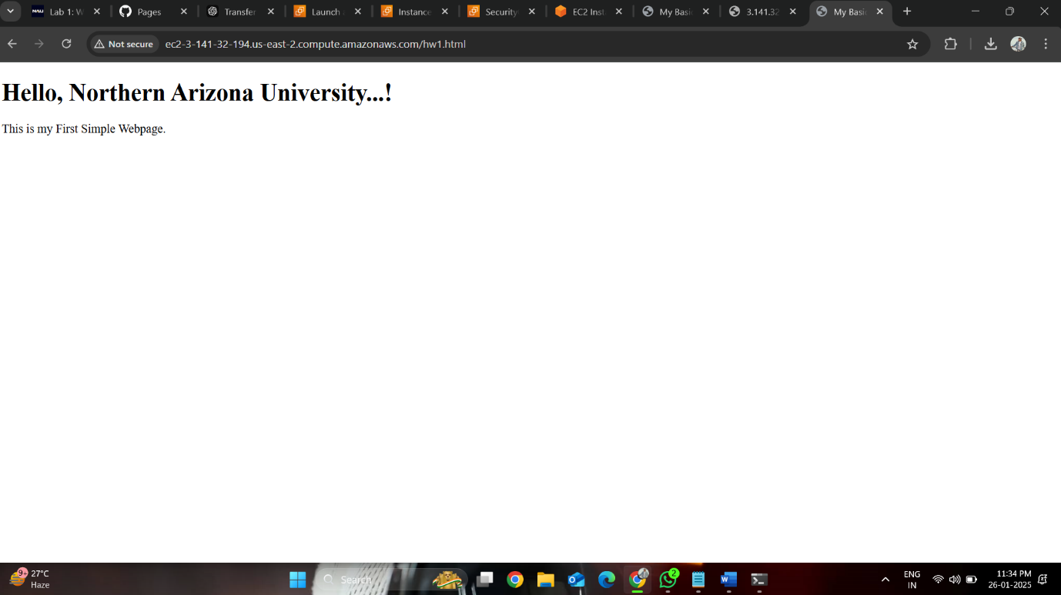
Link: http://ec2-3-141-32-194.us-east-2.compute.amazonaws.com/hw1.html
Source Code

<!DOCTYPE html>
<html>
<head>
<title> My Basic web page</title>
</head>
<body>

<h1> Hello, Northern Arizona University...! </h1>
<p> This is my First Simple Webpage.</p>
</body>
</html>

Analysis of Web Server Setup Process:

What went right:
The deployment of the local host server using Node.js was a straightforward and efficient process. Writing a basic Node.js script and serving the HTML page worked as expected, making it a great way to understand the basics of hosting a webpage locally. Setting up the webpage using GitHub was also a smooth process due to the clarity of the provided instructions, allowing for a seamless deployment.

Challenges faced and what went wrong:
Deploying the webpage on Azure was more complex than the local host. Configuring the pipeline for a Static Web App required some effort, particularly in linking GitHub to Azure and managing the deployment workflow. AWS was the most time-consuming platform to work with. Issues with the EC2 instance, such as misconfigured security group rules and difficulties enabling public access, caused significant delays. Troubleshooting these problems required researching specific solutions and adjusting settings multiple times.

What I need to learn more about:
I need to build a stronger understanding of Node.js for more advanced server configurations, such as handling dynamic requests and setting up additional features. On the cloud server side, I aim to learn more about effectively configuring instances, managing permissions, and automating deployments on platforms like AWS and Azure.

